


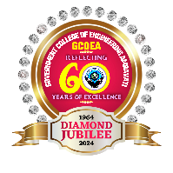
GOVERNMENT COLLEGE OF ENGINEERING AMRAVATI
(An Autonomous Institute of Govt. of Maharashtra)
“Towards Global Technological Excellence”
Phone: 0721-2531930 Fax: 0721-2531931
Website: www.gcoea.ac.in Email: principal@gcoea.ac.in

Appendix V: Student Diary (Log) Recording Format

Week | Task Assigned | Activities Performed | Key Learnings | Additional Remark
1 | Visiting every station of manufacturing process of a solar panel. | Observing how process works. | Time management
2
3
4
5
6
7
8
9
10
11
12
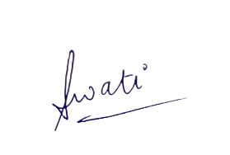
Signature & Name of Industry Internship Supervisor: Swati Kulkarni Sign:

